What is a table maintenance generator?

SAP Table Maintenance Generator (TMG) is a tool, used to create a table maintenance program, which can be customized, to be used by the end users to maintain the table for example, user can create a new entry in the table, can change the existing data, and can delete the data.   
  
To create Table Maintenance Generator (TMG) you can go to SE11 t-code and then enter the table name and then click on change button. Go to Utilities -> Table Maintenance Generator.

Alternatively, you can access directly by using transaction code - SE54.

**Why we need to use Table Maintenance Generator?**

In production systems, the end-users generally do not have access to SE11 or Se16 transaction code. So, if they need to maintain this table, they need an alternate way to do so.

Users have access to only SM30 for entries. This is possible only if TMG is created.

to change the view of data browser in se11. need to change the view of output.

first goto se16

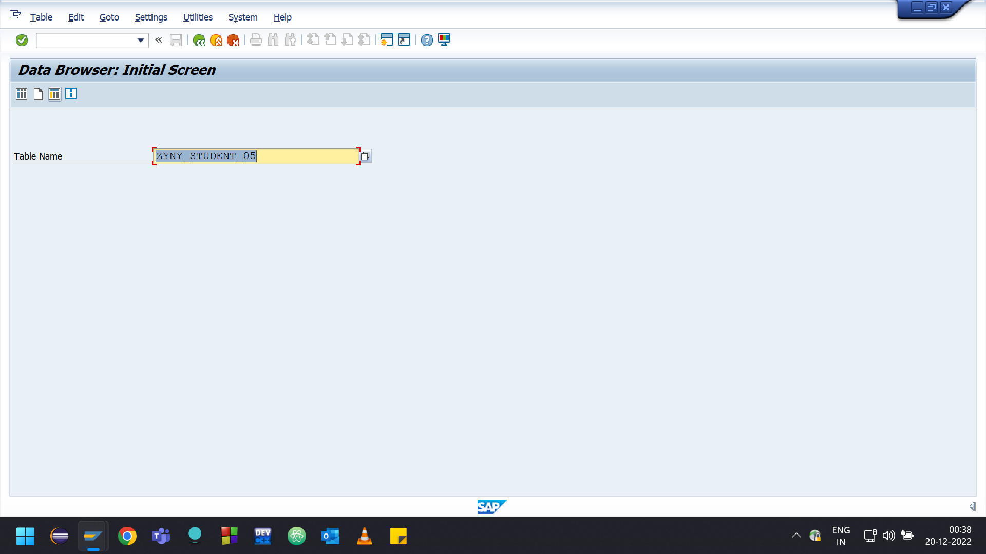

click on button User Parameters

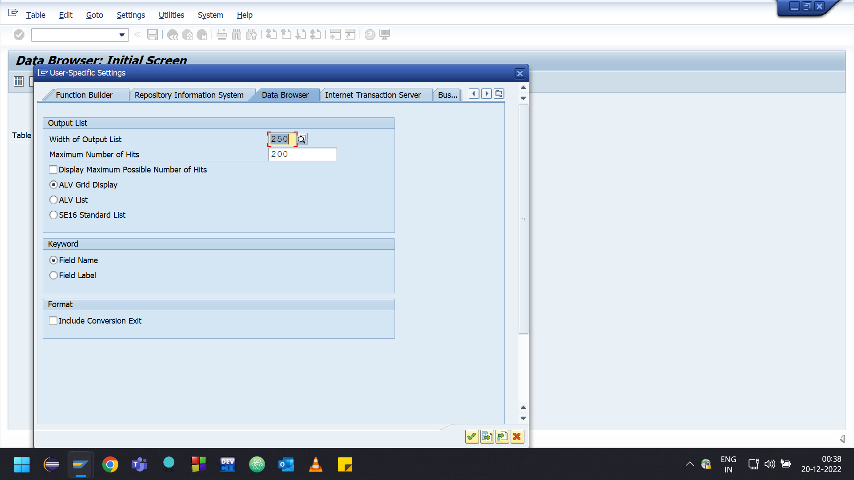

you can change the view to any alv grid display, alv list, se16 standard list